

University of St.Gallen

School of Management, Economics, Law, Social Sciences and International Affairs

Data Analytics II: PC2

University of St. Gallen

Jonas Husmann | 16-610-917

Niklas Leander Kampe | 16-611-618

Prof. Dr. Michael Lechner

March 07, 2022

**Part 1: Data Preparation**

1. Load Data Set

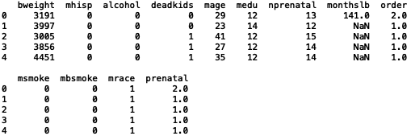

1. Summary Statistics and Histograms + Anomalies or Missing Values

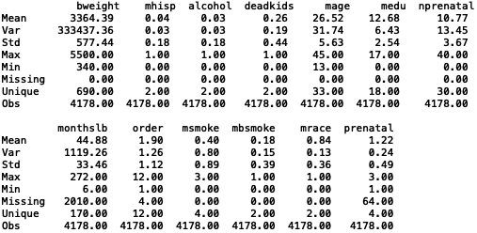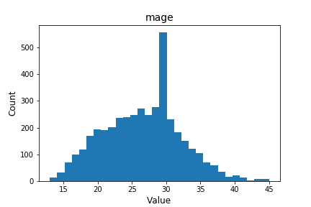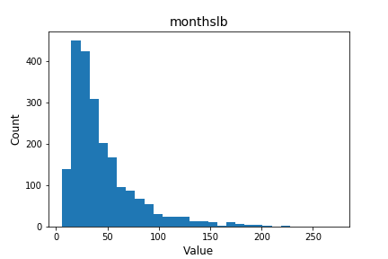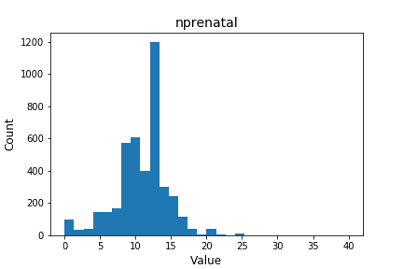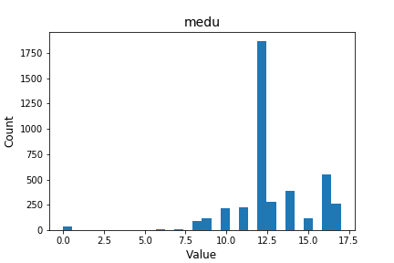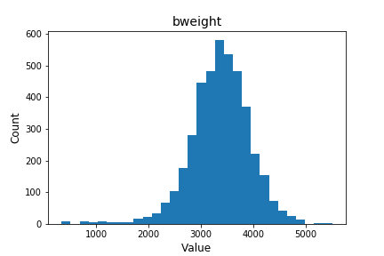

From the summary statistics above, it’s observable that all dummy variables are coded correctly, which can be seen from the min-value of 0, max-value of 1 and the number of unique values of 2. Furthermore, the (continuous) variables “bweights”, “mage”, “medu”, “nprenatal”, “monthslb”, “order”, “msmoke” and “prenatal” seem also to have no anomalies since the min-, max- and number of unique values match the variable definition and their description (e.g., variables coded on a 3-step interval have indeed 3 unique values or reasonable birth weights). These observations are underlined by the histograms. While the target variable “bweight” shows a relatively even distribution, the covariates “monthslb” and “nprenatal” are slightly positively skewed and the covariates “mage” and “modu” are slightly negatively skewed, but they do not seem to have significant impact for further statistical/econometric analysis. Only potential outliers can be identified, i.e., in “modu”, on which it can be potentially decided if the observations should be omitted. Finally, the only unreasonable value in the data set is given by the min-value of the “monthslb” of 6, which is defined as six months since the birth of the last child, which generally cannot be true. Otherwise, no more data major anomalies can be determined in the data set.

Next to that, the summary statistics identify missing values for the covariates “monthslb”, “order” and “prenatal”. In this context, it is important to mention that the variable “monthslb” has a very significant proportion of missing values, which suggest to rather ignore this covariate instead of omitting the missing observations, due to an otherwise significant reduction of the data set.

Lastly, the mean value of the dummy variable “mbsmoke”, which is defined as the treatment variable, of 0.18 shows that 18% of the sample refers to the treatment group, while the remaining 82% refer to the control group. This suggest a significant treatment-control imbalance, which will be further discussed at a later stage.

1. Variable and Observation Drops for Missing Values

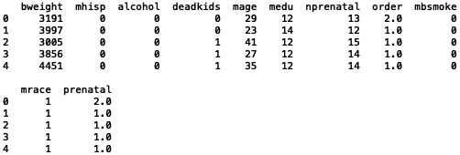

1. Dummy Variable Recoding

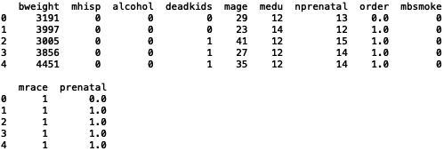

1. Summary Statistics + Suitability for Econometric Analysis

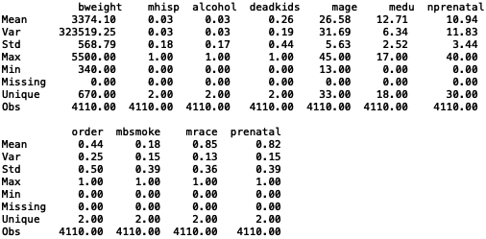

According to the updated summary statistics, the data set does not contain any missing values for all variables. Furthermore, all dummy variables are coded correctly, which can be seen from the min-value of 0, max-value of 1 and the number of unique values of 2. Additionally, all non-dummy variables have non-problematic sample distributions and do also only contain reasonable values, which can be determined based on min-, max- and number of unique values matching the variable definition and their description (e.g., variables coded on a 3-step interval have indeed 3 unique values or reasonable birth weights). Any potential anomalies, which have been identified in task 1a, are also solved. Lastly, the variables “mhisp” and “alcohol” seem to be significantly imbalanced in the whole data set, with only 3% each having a “positive label”. Hence, conclusions from an econometric analysis from these two variables can be difficult based on the distribution and the sample size. Finally, no more major issues can be identified for further econometric analysis.

1. Balancing Checks

Ein Bild, das Tisch enthält.

As given by the definition of the balancing checks, any standardized differences above 10 are considered as large with a predetermined confidence level of 0.05. According to the table above and hence the balancing checks on the covariates (measure “StdDiff”), the variables “alcohol”, “deadkids”, “mage”, “medu”, “nprenatal”, “order” and “prenatal” are determined to have a significant standardized difference between the treatment and control group. Furthermore, all standardized differences of the imbalanced variables are negative, despite of “alcohol” and “deadkids”. This implies that the mean values of the treatment group are lower than those of the control group for all imbalanced variables except for “alcohol” and “deadkids”. The other variables, “mhisp” and “mrace”, can be considered as the only balanced covariates in the data set.

Based on these results, it can also be concluded that the data set includes potential multicollinearity in the covariates, e.g., that women who drink alcohol are also likely to be smoking during pregnancy. Such multicollinearity can have major impacts on statistical and econometric statistics and resulting conclusions, e.g., in biased predictors while estimating the effect of the covariates on the target variable. Additionally, as the only two covariates without imbalanced proportions in the treatment and control group are “mhisp” and “mrace”, the major channels for selections in this sample is likely to be the origin/race of the individuals, which might lead to a selection bias in the sample data set with effects on the degree of randomization.



According to the balance checks on the target variable “bweight”, the large, standardized difference of -47.66 is highly significant with a p-value of 0. Furthermore, the negative sign implies as well that the mean value in the treatment group is lower than the mean value in the control group. Hence, the target variable can be determined as imbalanced between the treatment and the control group in the data set.

**Part 2: Effect Estimation**

1. OLS Function for ATE Estimation without Covariates
2. OLS Function for ATE Estimation with Covariates